

Photoshop

Designers

Illustrator

○





**Trần Việt Hoàng**

[cunngo2000@gmail.com](mailto:cunngo2000@gmail.com) Tham gia: 02-08-2022

* Thành phố Đà Nẵng

Thông tin

Giáo dục

Kinh nghiệm làm việc

Portfolio

Kỹ năng nghề nghiệp

Giải thưởng

# Thông tin

Thích chơi cờ vua

# Giáo dục

University

○

2008 - 2012

Middle East Technical University

Computer Science

Lorem ipsum dolor sit amet, consectetur adipiscing elit. Proin a ipsum tellus. Interdum et malesuada fames ac ante ipsum primis in faucibus.

High School

○

2008 - 2012

Tomms College

Bachlors in Fine Arts

Lorem ipsum dolor sit amet, consectetur adipiscing elit. Proin a ipsum tellus. Interdum et malesuada fames ac ante ipsum primis in faucibus.

# Kinh nghiệm làm việc

Web Designer Inwave Studio



2008 - 2012

Lorem ipsum dolor sit amet, consectetur adipiscing elit. Proin a ipsum tellus. Interdum et malesuada fames ac ante ipsum primis in faucibus.

CEO Founder Inwave Studio

2008 - 2012

Lorem ipsum dolor sit amet, consectetur adipiscing elit. Proin a ipsum tellus. Interdum et malesuada fames ac ante ipsum primis in faucibus.

# Portfolio

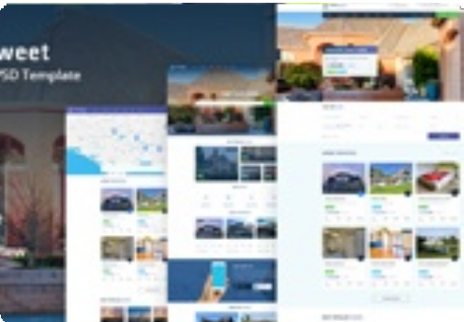



|  |  |  |
| --- | --- | --- |
| **Kỹ năng nghề nghiệp** |  | |
| Adobe Photoshop |  | 80% |
| Production In Html | 60% |  |
| Graphic Design |  | 75% |
| **Giải thưởng** |  |  |

Perfect Attendance Programs



2008 - 2012

Lorem ipsum dolor sit amet, consectetur adipiscing elit. Proin a ipsum tellus. Interdum et malesuada fames ac ante ipsum primis in faucibus.



Top Performer Recognition

2008 - 2012

Lorem ipsum dolor sit amet, consectetur adipiscing elit. Proin a ipsum tellus. Interdum et malesuada fames ac ante ipsum primis in faucibus.

King LLC

2008 - 2012

Lorem ipsum dolor sit amet, consectetur adipiscing elit. Proin a ipsum tellus. Interdum et malesuada fames ac ante ipsum primis in faucibus.